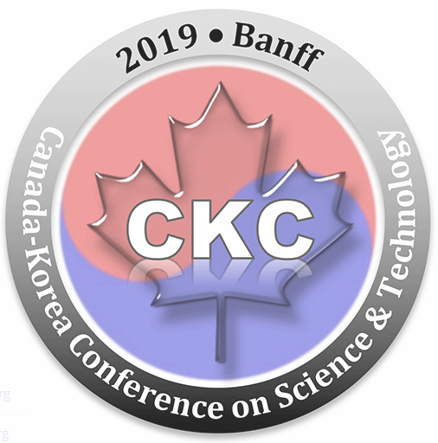
CKC 2019 Young Generation Programs
CALL FOR APPLICATIONS

Please use an 11-point Times New Roman at single space to fill out this form. Deadline for application submission: Apr. 15, 2019

- Participant’s Personal Information
Name, first (full), middle (or initials, if used), last name:
Title:
Affiliation/School:
Affiliation address:
Name of YG or YP Chapter:
Year of Studies/Program (Undergraduate or Graduate) or Final degree:
Cumulative GPA (for undergraduate and graduate students only):
E-mail: Telephone: Have you participated in previous year’s YGP/YSEC? No ____ YES ____, if YES, which year _______
- Participation Type
□ Research Competition* Oral or Poster (check)
□ Entrepreneurship Competition
□ Industry Talk¥
Note: *250-word abstract required that includes introduction, methods, results, conclusions of the research study; only selected abstracts will be invited to the oral sessions. The oral presenters are required to present in the poster session as well.
¥This program includes a general talk for industrial members. Topics can be informative and beneficial to fellow professionals and students such as “what to do at work”, “the introduction to the workplace”, or “industrial career paths”.
- Travel Support
Please indicate if you require following partial travel supports:
□ Accommodation at the conference site (4 people per room)
□ Zone based travel support
Note: Selected AKCSE members (YG or YP) will be provided with accommodation and meal support (during the conference) as well as zone-based partial travel support and a reduced registration fee ($50) to CKC. Accommodation and zone-based travel supports will be applied to non-local participants only.
- Research Topic/Session Area (check one)
□ MAE – Mechanical, Civil & Aerospace Engineering
□ ICT - Information & Communication Technology
□ MNT – Materials, Physics, Chemistry and Nano Technology
□ BSH – Biological Sciences and Health
□ Others - (if not listed in the above areas; add specific topic area)
- Abstract
Please use the sample format provided below (up to 250 words)
Please return this form by email no later than April 15, 2019 to the program committee (ygp@akcse.org and cc to Dr. Patrick Lee patricklee@mie.utoronto.ca).
Cyclolinopeptides Compounds as Chemotherapy Agents

Jin-Hee Chang¹, Martin J.T. Reaney^{2,3}, Youn Young Shim^{2,3}*

¹College of Life Sciences and Biotechnology, Korea University, Seoul, Korea, ²Department of Plant Sciences, University of Saskatchewan, Saskatchewan, Canada, ³Prairie Tide Chemicals Inc., Saskatchewan, Canada

Flax (Linum usitatissimum L.) seed has been associated with numerous health benefits. The flax plant synthesizes an array of biologically active cyclic peptides or cyclolinopeptides (CLs) from two ribosome-derived precursors. CLA for instance, suppresses immunity, induces apoptosis in human epithelial cancer cell lines, and inhibits T-Cell proliferation. The mechanism of action of CLA is unknown. The immunosuppressive activity of CLs and analogues make them potential value-added natural products of flaxseed and should lead to further investigation of their biological activity. Microarray and gene expression analysis indicate that CLs exert their activity, in part, through induction of apoptosis. Responses to CL exposure include: 1) induction of heat shock protein (HSP) 70A production in Caenorhabditus elegans. Exposure of nematode cultures to CLA (0.1 µM and 10.0 µM) induced a 30% increase in the production of the HSP 70A protein, while a 3.5-fold increase was induced in the culture treated with 1.0 µM of CLA; 2) induction of apoptosis in human lung epithelial cancer lines; and 3) modulation of regulatory genes in apoptosis in human lung epithelial cancer lines. These diverse activities indicate that CLs could induce apoptosis in cancer cells or act as versatile platforms to deliver a variety of biologically active molecules for cancer therapy. *Corresponding author; E-mail younyoung.shim@ usask.ca
Maximum-250 words

Poster Presentation Instruction
Upon confirming the receipt of acceptance for CKC 2019 poster presentation, please review the following information to prepare your poster. Please keep in mind that all presenters are responsible to print their own posters.
Fonts: You may choose any font style (e.g. Garamond, Arial and Times New Roman).
- Posters should be readable from at least three feet away.
- Headings no smaller than 34 point type.
- Text no smaller than 24 point type.
Poster Size: A poster board (36’’W x 48’’H – Portrait) shown below and thumbtacks will be provided.
- Title of poster.
- Authors, affiliations and contact details (email address, postal address).
- A body of 200-250 words in the abstract.
- 3-6 key words.
Illustrations: Position figures and tables at the tops and bottoms of columns, if possible. Large figures and tables may span both columns. Figure captions should be below the figures; table captions should be above the tables. Try to place the figures and tables after their first mention in the text. Use the abbreviations (e.g. “Fig. 1”) even at the beginning of a sentence.
References: Samples:
- Saleh M.A. et al., Physics and Chemistry of Liquids 2001; 39: 551-563.
- Morita H. et al., Phytochemistry 2001; 57: 251-260.
Poster Sample

Title of the abstract: upper and lower case, bold, centered, font Times New Roman 14 pt. Enter one clear line before the authors. Author(s’) name(s): first name (full), middle name (or initials, if used), last name (surname, family name), and without title or occupation, bold, centered, font Times New Roman, 11 pt. For multiple authors, type superscript numbers after the last letter of the author's names. Enter one clear line after the authors. Affiliation: italic, upper and lower case, centered, Times New Roman, 11 pt. Provide the complete mailing address of affiliation, including the province and country names of each affiliation. For multiple authors at different affiliations, type superscript numbers in front of the first letter of each author's address. Enter one clear line after the affiliation. Corresponding author: Clearly indicate who will handle correspondence at all stages of publication for CKC 2019 proceeding booklet.

